**MID TERM II EXAMINATION - 2022**

**INTEGRATED SCIENCE**

**PRIMARY FIVE**

***Time allowed: 2 Hours 15 Minutes***

Name: ………………………………………………………………..................... Stream:………………………………

**Read the following instructions carefully.**

|  |  |  |
| --- | --- | --- |
| **FOR EXAMINERS’ USE ONLY** | | |
| **Qn. No.** | **MARKS** | **EXR’S NO.** |
| **1 – 10** |  |  |
| **11 – 20** |  |  |
| **21 – 30** |  |  |
| **31 – 40** |  |  |
| **41 – 43** |  |  |
| **44 – 46** |  |  |
| **47 – 49** |  |  |
| **50 – 52** |  |  |
| **53 - 55** |  |  |
| **TOTAL** |  |  |

1. This paper has two sections **A** and **B.**
2. Section **A** has **40** short questions (40 marks)
3. Section **B** has **15** questions (60 marks)
4. Answer **ALL** questions. All answers to both sections **A** and **B** must be written in spaces provided.
5. All answers must be clearly written using blue or black ball point pen or ink. Only diagrams should be drawn in pencil.
6. Unnecessary changes of work may lead to loss of marks.
7. Do not fill in the boxes. They are for examiners’ use only.

**SECTION A**

1. Name the type of soil with the finest particles.

……………………………………………………………………………………….

2. Mention one class of food which is not digested in the human

digestive system.

……………………………………………………………………………………….

3. Give one example of an insect vector.

……………………………………………………………………………………….

4. State one way in which sunny weather is useful to people.

……………………………………………………………………………………….

5. How does mulching maintain moisture in the soil?

……………………………………………………………………………………….

**The diagram below shows a plant with a creeping stem. Use it to**

**answer the questions 6 and 7.**

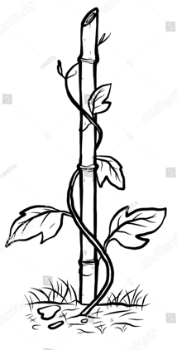

6. Name the method of climbing by plants shown in the diagram.

……………………………………………………………………………………….

7. Write another way in which plants with weak stems climb others.

……………………………………………………………………………………….

8. What advice can you give to a mother whose child has poor night

vision?

……………………………………………………………………………………….

9. State one importance of cotyledons to the embryo of a germinating

bean seed.

……………………………………………………………………………………….

10. How are earth worms important in the soil?

……………………………………………………………………………………….

11. Why do hookworms lead to anaemia to people who have them?

……………………………………………………………………………………….

12. State one way of rehydrating a person.

……………………………………………………………………………………….

13. Why is it dangerous to leave windows and doors open during

evening hours?

……………………………………………………………………………………….

**The diagram below shows a garden tool. Use it to answer**

**questions 14 and 15.**

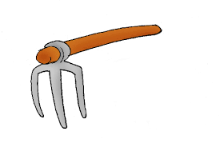

14. Name the garden tool shown above.

……………………………………………………………………………………….

15. State the function of the above garden tool to the crop farmers.

……………………………………………………………………………………….

16. State one way in which shadows are important to a primary five

pupil.

……………………………………………………………………………………….

17. Why is feather able to float on water?

……………………………………………………………………………………….

18. Give one role of prefects in promoting sanitation at school.

……………………………………………………………………………………….

19. Which type of chicken is kept for commercial egg production?

……………………………………………………………………………………….

20. What first aid can you give to a fellow pupil with a scalded leg?

……………………………………………………………………………………….

**Study the diagram below about air and use it to answer**

**questions 21 and 22.**

**B**

**A**

21. Which property of air is shown by balloon **A** but not balloon **B**?

……………………………………………………………………………………….

22. Why is the beam balance bent towards the side of balloon **A**?

……………………………………………………………………………………….

23. Mention one part of the alimentary canal where mechanical

digestion takes place.

……………………………………………………………………………………….

24. Give one sign of measles.

……………………………………………………………………………………….

25. Mention one component of soil.

……………………………………………………………………………………….

26. In which way does a chameleon protect itself against enemies?

……………………………………………………………………………………….

27. How is the queen protected in the beehive?

……………………………………………………………………………………….

28. Write one way in which poultry farmers use maize.

……………………………………………………………………………………….

29. State one way of promoting oral hygiene.

……………………………………………………………………………………….

30. Which term refers to substances which dissolve in solvents?

……………………………………………………………………………………….

31. Where in a flower are female reproductive cells produced?

……………………………………………………………………………………….

32. Name the type of teeth used for cutting food.

……………………………………………………………………………………….

33. State any one danger of failure to groom finger nails.

……………………………………………………………………………………….

34. Give the state of matter where smoke belongs.

……………………………………………………………………………………….

35. In which way are sugarcane planted?

……………………………………………………………………………………….

36. Why are windows put on the buildings?

……………………………………………………………………………………….

37. State one danger of living in bushy areas.

……………………………………………………………………………………….

38. How is posho useful in the body?

……………………………………………………………………………………….

39. Give one example of a faecal disease.

……………………………………………………………………………………….

40. State the function of the smoker to a honey harvester.

……………………………………………………………………………………….

**SECTION B**

41. (a) Apart from loam soil, mention two other types of soil.

(i)……………………………………… (ii)…………………………………

(b) Give one reason why loam soil is able to support proper plant

growth.

………………………………………………………………………………………

(c) State one way of controlling soil erosion in the school compound.

.......................................................................................................

**The diagram below shows a tool used to give first aid. Use it to**

**answer question 42.**

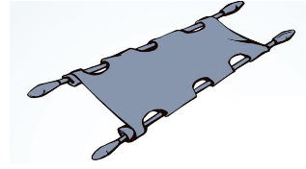

42. (a) What kind of accident victims require the use of the first aid tool

above?

……………………………………………………………………………………….

(b) Why can’t the first aid tool above be put in a first aid box?

……………………………………………………………………………………….

(c) State any one danger of giving first aid in a dirty place.

……………………………………………………………………………………….

(d) Mention any one local material used to make the above first aid

tool.

……………………………………………………………………………………….

43. **The diagram below shows the arrangement of molecules in**

**three states of matter**. **Study it carefully and answer questions**

**that follow.**

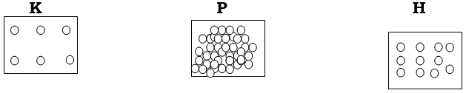

(a) Name the state of matter marked with letter **K**.

……………………………………………………………………………………….

(b) Which form of energy can change state of matter **H** to **K**?

……………………………………………………………………………………….

(c) State one difference between the arrangements of molecules in

state of matter **K** and **P.**

……………………………………………………………………………………..

.........................................................................................................

(d) Why are molecules in diagram labelled **P** closely held together?

……………………………………………………………………………………….

44. (a) Apart from polio, mention one other childhood disease immunized at birth.

……………………………………………………………………………………….

(b) Which type of germs cause the immunisable disease named in

(a) above?

……………………………………………………………………………………….

(c) State two other ways of controlling diseases in infants.

i)………………………………………………………………………………………

ii)……………………………………………………………………………………

**45. The table below shows ways of caring for crops. Use it to**

**answer questions that follow.**

|  |  |  |  |
| --- | --- | --- | --- |
| **A** | **B** | **C** | **D** |
| weeding | pruning | spraying | thinning |

(a) Identify the practice from the table that helps to reduce on the

rate of transpirtation.

……………………………………………………………………………………….

(b) Mention any one group of chemicals which can be used in

practice **C**.

……………………………………………………………………………………….

(c) Why should practice **A** be carried out early enough?

……………………………………………………………………………………….

(d) How else can a crop farmer control crop pests apart from using

practice **C**?

……………………………………………………………………………………….

46. **Match the following tools used to promote personal hygiene in**

**A with their uses in B.**

**A B**

(i) Toothpaste removing sweat from the skin

(ii) Razor blade kills germs in the mouth

(iii) Towel grooming finger and toe nails

(iv) Handkerchief drying the skin after bathing

(i) Toothpaste ………………………………………………

(ii) Razor blade ……………………………………………… (iii) Towel ………………………………………………

(iv) Handkerchief ………………………………………………

47. (a) Mention two materials collected by honey bees from the

environment.

i)………………………..……….…… ii)………..…………………………..

(b) State any two ways in which keeping bees is useful in our

community.

i)…………………………………………………………………………………….

ii)…………………………………………………………………………………….

48. (a) Name two forms of energy produced by a working candle.

i)………………………………………………………………………………………

ii)……………………………………………………………………………………..

(b) Why is the candle commonly used by people in rural areas?

……………………………………………………………………………………….

(c) Mention the component of air which supports the burning candle.

……………………………………………………………………………………….

49. (a) State two ways in which food is useful in the human body.

i)………………………………………………………………………………………

ii)……………………………………………………………………………………

(b) Which class of food helps to boost up the body immunity?

……………………………………………………………………………………….

(c) State one danger of failure to feed on a balanced diet to the

body.

……………………………………………………………………………………….

50. (a) Name one breed of rabbits.

……………………………………………………………………………………….

(b) State one reason why people keep rabbits.

……………………………………………………………………………………….

(c) Give any two ways in which diseases in rabbits can be

controlled.

i)………………………………………………………………………………………

ii)……………………………………………………………………………………

**The diagram below shows a lifecycle of a mosquito. Use it to**

**answer question 51.**

**B**

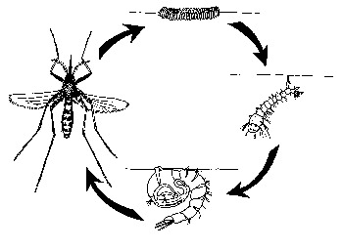

**D**

**C**

**A**

51. (a) Name the type of metamorphosis shown above.

……………………………………………………………………………………….

(b) Which stage in the diagram above is dangerous to people.

……………………………………………………………………………………….

(c) How is the life cycle shown above different from that of a

cockroach?

……………………………………………………………………………………….

(d) State any one way of controlling mosquitoes at home and

school.

……………………………………………………………………………………….

52. (a) Name two body organs found in the chest cavity.

i)………………………………………………………………………………………

ii)……………………………………………………………………………………..

(b) Write any two ways of keeping all body organs healthy.

i)………………………………………………………………………………………

ii)……………………………………………………………………………………

**The experiment below was carried out by a P.5 pupil during a**

**science lesson. Study it and answer question 53.**

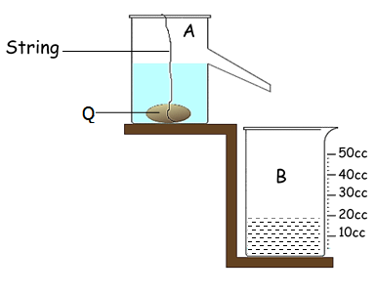

53(a) Mention the group of objects in which object **Q** is classified.

……………………………………………………………………………………….

(b) What is the volume of object **Q** according to the diagram?

(c) Why is the volume of objects such as **Q** found using the method

shown above?

……………………………………………………………………………………….

(d) State the standard unit for measuring mass.

……………………………………………………………………………………….

54. (a) Mention the parts of digestive system where the following

digestive juice are produced.

i**) bile juice** ……………………………………………………………………….

**ii) gastric juice**…………………………………………………………………..

(b) State one way in which bile juice is important during digestion of

food.

……………………………………………………………………………………….

(c) Mention any one way of controlling disorders of the digestive

system.

……………………………………………………………………………………….

55. (a) Write **PIASCY** in full.

……………………………………………………………………………………….

……………………………………………………………………………………….

(b) Mention any two messages emphasized under **PIASCY**.

i)………………………………………………………………………………………

ii)……………………………………………………………………………………..

(c) Mention the disease that **PIASCY** aims to control amongst the

youths.

……………………………………………………………………………………….

**END**